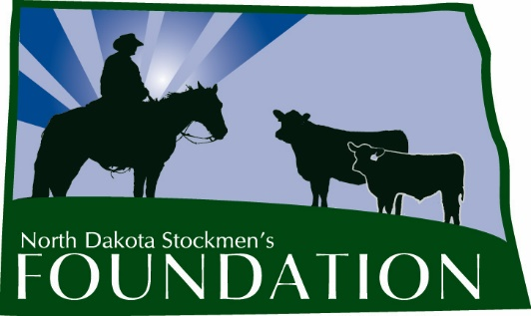

NORTH DAKOTA STOCKMEN’S FOUNDATION LEGACY SCHOLARSHIP

NAME: The name of this scholarship is the North Dakota Stockmen’s Foundation Legacy Scholarship.

PURPOSE: The purpose of this scholarship is to provide a source of financial support for a student who is a member of or the child of a member of the North Dakota Stockmen's Association.

INCLUDES: The scholarship will be for $500 and will include a one-year membership in the North Dakota Stockmen’s Association.

ELIGIBILITY: Students eligible for this scholarship will:
1. At the time of application, be a high school senior, a college freshman, sophomore or junior.
2. Have an interest in the beef cattle industry of North Dakota.
3. Be a member or a child of a member of the North Dakota Stockmen’s Association.
4. Have a G.P.A. of 2.0 or greater.
5. Submit a completed application to the North Dakota Stockmen's Foundation. Emailed applications will not be accepted.

MANNER AND TIME OF CHOICE:
The deadline to submit applications to the North Dakota Stockmen’s Association office is March 1 of each year. Payment will be made following enrollment in the fall semester.

FUNDING: Upon selection of the recipient, the North Dakota Stockmen’s Foundation will forward a check for the amount of the award to the college or university development foundation. The Foundation will make the scholarship payment upon authorization by the office of student financial aid.

GUIDELINES: 1. The Scholarship Selection Committee will be made up of the NDSF advisory committee chairman and at least three other livestock industry professionals.

2. Any changes deemed necessary must be made by the North Dakota Stockmen’s Foundation Board of Directors.

3. The winner will be published in the North Dakota Stockman and other publications and if possible, be recognized at the annual convention in order to give the winner and the North Dakota Stockmen’s Foundation as much positive publicity as possible.

4. Application will include:
a. A description of the applicant’s involvement in his or her school and community (activities, organizations, awards, etc.)
b. Why the applicant chose his or her current major.
c. How the applicant will contribute to a bright future for the cattle industry.
d. What the applicant’s plans are for the future.
e. How the applicant's or the applicant's parent's involvement in the North Dakota Stockmen's Association influenced his or her future plans.
LEGACY SCHOLARSHIP

First Name: Middle Initial: Last Name:
Home Address:
Current Grade: School Address:
Home Phone: Cell Phone: School Phone:
Parent's Name & Address:
Birthdate: High School GPA: College GPA:
Major/Minor:
Reason for applying for scholarship:
Other scholarships you have received and the dollar amounts of the scholarships:
Why did you choose your current major?
How will you contribute to a bright future for the cattle industry in North Dakota?
What are your plans for the future?
How did you or your parents' involvement in the North Dakota Stockmen's Association influence your future plans?
Describe your involvement in your school and community (activities, organizations, awards, etc.):
ON A SEPARATE SHEET: Discuss an issue important to North Dakota cattle producers.
Provide two letters of reference and transcript (must be included with application).
Signature:

Completed application should be submitted by March 1 to:

North Dakota Stockmen’s Foundation Legacy Scholarship
c/o North Dakota Stockmen’s Association
407 South 2nd Street
Bismarck, ND 58504

